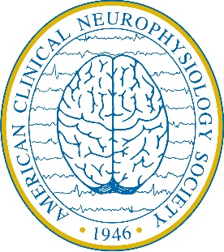
American Clinical Neurophysiology Society (ACNS)
Fall Courses
October 17-18, 2020
San Diego, CA

Speaker Housing Reservation Form
Loews Coronado Bay

First Name: Last Name:

HOUSING ARRANGEMENTS

I will make my own housing arrangements and will submit an original receipt following the Fall Courses for reimbursement. I understand reimbursement will be made at the meeting hotel rate of $244/night – or below, for a maximum of two nights.

Please make my reservation as follows at the Loews Coronado Bay. I understand that ACNS will pay for the cost of my room and tax only for two nights, and that any additional nights or incidentals incurred will be my responsibility. I understand that check-in time is at 3:00pm, on the day of my arrival; and check-out time is at 12:00pm (noon), on the day of my departure. *If I would like to request an early or late check in/out, I will contact the Loews Coronado Bay at (619) 424-4000 to do so.

Check-in Date: Check-out Date:

ACCOMMODATION PREFERENCES
Please note that ACNS will reserve one standard room under your name, up to double occupancy. Additional rooms required for family, guests, or accompanying persons should be reserved on the Housing tab at http://www.acns.org/meetings/fall-courses/2016/housing-travel-information

Single/Double Occupancy: King Double/Double

Smoking/Non-Smoking: Non-Smoking Smoking

SPECIAL NEEDS
Please indicate any special needs or requests

Please return this form no later than September 1, 2020 to:
American Clinical Neurophysiology Society
555 E. Wells Street, Suite 1100 • Milwaukee, WI 53202
Fax: +1-414-276-3349 • Email: info@acns.org

The reservation cut-off date at the Loews Coronado Bay is September 24, 2020. ACNS cannot guarantee that rooms will be available, at the group rate or otherwise, after September 24.
Thank you!

